**Sarah Sprole**

**Excel Homework**

**11/26/2018**

**Three Conclusions that can be made about Kickstarter campaigns given the provided data:**

1. Staff picks are more successful than non-staff pics. As viewed in the following data, 87% of “staff pics” are successful while only 12% of them failed. On the other hand, “non-staff pics” are only 48% successful and 41% failed. Now, a limitation to this is what exactly does “staff pick” mean? Are they projects Kickstarter staff has found? Or are they projects that the staff favor over other projects? If they do favor certain projects over others, are they doing something within the company that makes these “staff pics” more successful?

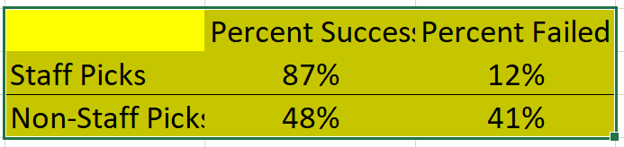

1. The most successful projects come from the categories “Theater” and Music”. Though these are among the most successful, they still have fairly high failure rates compared to success, which brings me to the 3rd conclusion.

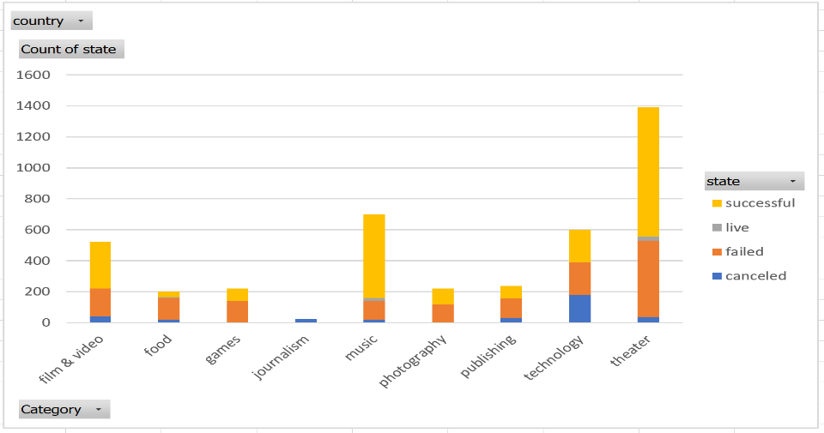

1. Within a couple of these categories are a couple of sub-categories that are much more successful than the other sub-categories, such as “Rock” and “Indie Rock” in the Music category and “Plays” in the Theater category.

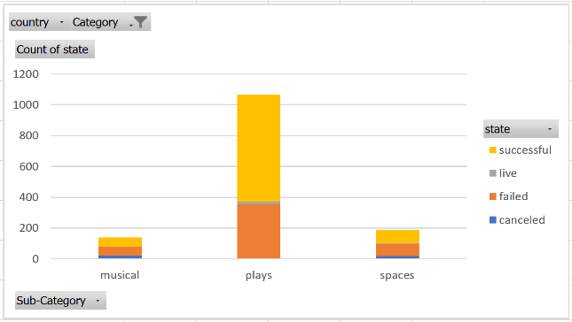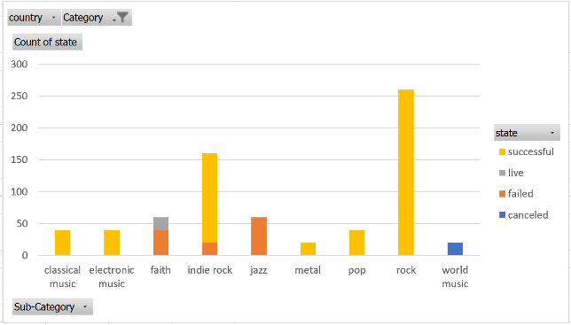

**Limitations of this dataset:**

* There is no way to know what makes projects successful or unsuccessful.
* No other social or economic background is given on those trying to kickstart projects other than “country”. Are people successful because of their ideas? Or do they have friends/family/support system to initially back them? Also, going back to the point made earlier, are “staff pics” affecting the success and failure of projects? Does this make it an uneven playing field?
* What percentage of the money raised actually goes to the project? How much does Kickstarter charge or take out for their fee?
* In looking at the “Categories” pivot chart, “Film & Video” and “Tech” appear to be relatively successful; however, when filtering to these categories on the “Sub-Categories” pivot chart, there are no successful sub-categories within these categories. Why?

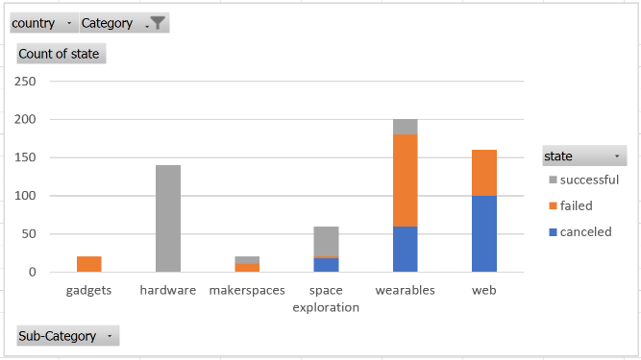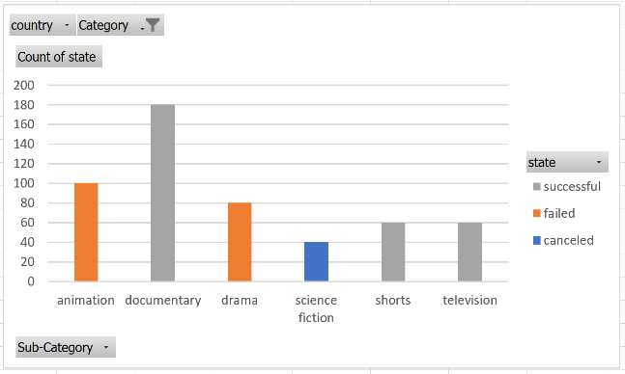

**Other tables and graphs we could use:**

Scatter plots could be used to compare different value sets for states, such as successful, failed, and canceled projects. This type of chart could also be used to understand distribution of data, such as successful, failed, and cancelled projects over the years. Pie charts could be used to visualize what percentage each category makes up of the total number of projects; however, a pie chart could not be used for the sub-categories because there are too many and they would clutter up the chart.